Lesson plans 5 and 6: Malaria in Kitanga
About the lessons
This double lesson picks up the story from the end of the last lesson. A real-life scenario is used to illustrate how the algorithm created by Dr Snow in Soho in 1854 can be applied to a medical emergency in East Africa today. Students are introduced to the process of generalisation, whereby an algorithm created to solve one problem can be applied to solve any number of different but similar problems.
Generalisation is extremely common in computer programming. Rather than write all the code for every application they produce, software developers seek out code that does something very similar to what they want and then repurpose it. This is an efficient way of working.
These lessons also provide opportunities for the students to consolidate their knowledge and understanding of the four cornerstones of computational thinking: decomposition, abstraction, pattern recognition and algorithm design.
As with Lesson 4, you may want to consider how you deliver these lessons if you have vulnerable students in your class given the challenges Covid-19 presented us with in 2020 and may still be presenting us with. Ultimately though, this is an opportunity to stress the how valuable algorithms can be in tackling health crises.
Learning objectives
By the end of this lesson, students will:
- apply the concepts of decomposition, abstraction, pattern recognition and algorithm design to a real-world problem
- collect and analyse data to identify the cause of a real-world problem and suggest a solution
- analyse different approaches to solving problems.
National curriculum
The following subject content from the KS3 National Curriculum is included in this lesson:
- Design, use and evaluate computational abstractions that model the state and behaviour of real-world problems and physical systems
- Understand several key algorithms that reflect computational thinking; use logical reasoning to compare the utility of alternative algorithms for the same problem
Links
Students who have completed the Introducing spreadsheets module will have covered the necessary skills for this unit. It might be useful to revisit these using the videos associated with that unit. The extension task requires knowledge of the Programming in Scratch module or the Python sequence module.

Key terminology
generalisation, decomposition, data collection, abstraction, pattern recognition
Teaching and learning activities
Share the objectives for the lesson with students (Slide 2 of Lessons 5 and 6 presentation).
Starter
Ask students to read the front page of the East African News and look at the map of Kitanga District (handout 5.1, slide 3).
Ask: How do you think Dr Snow might have approached the medical emergency in East Africa?
Listen to students’ answers but don’t correct any that are misguided at the moment. This is a brain-storming session to see what they come up with.
Show students the flow chart of Dr Snow’s algorithm (Slide 4 and page 96) and ask the question again: How do you think Dr Snow might have approached the medical emergency in East Africa?
Lead students to the idea of generalising Dr Snow’s algorithm and applying it to the malaria outbreak.
Explain the term generalisation and its relevance to computing and computer programmers (Slide 5 and page 96).
Tell students that they will carry out decomposition, data collection, abstraction and pattern recognition in order to identify the source of this malaria outbreak and decide which swamp or swamps should be sprayed with insecticide.
Part 1
Remind students of the first cornerstone of computational thinking, decomposition, and ask: What is the purpose of decomposition?
The purpose of decomposition is to break down a complex and seemingly impossible problem into smaller problems to gain a better understanding of it.
Ask: Give me some examples of decomposition from the previous lessons in this module.
Lesson 1: deconstructing a construction toy (if you did this), breaking down an everyday activity and taking apart a paper aeroplane. Lesson 2: analysing a flower design. Lesson 3: thinking about the car park algorithm and the traffic light algorithm. Lesson 4: investigating the Soho cholera outbreak.
Ask students to complete Activity 5.1: East African News (Worksheet 5.1, slide 6).
Answers
Students should identify the following as of particular interest to an epidemiologist:
the population of each village, the number of deaths, the number of mosquito net users, the number of people infected, the number of clinics, and the distance from each village to each swamp.
Part 2
Ask students to complete Activity 5.2: Data collection (Excel workbook 5.2; Google Sheets workbook 5.2, slide 7).
Answers
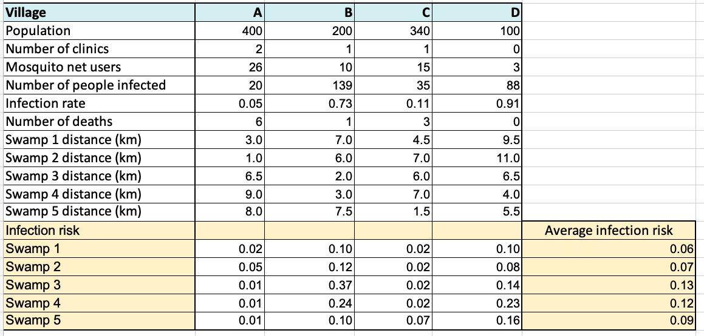
- Make sure students calculate the infection rate in each village correctly:
=B20/(B17-B19))
- Make sure students calculate the infection risk for each swamp correctly:
=B21/B23
- make sure students calculate the average infection risk correctly:
=AVERAGE(B29:E29)
Students will work at different paces, but the first lesson should end, and the second lesson should begin about here. Encourage slower students to catch up for homework. Use the guidance and answers provided below to support students who missed Lesson 5 so that they are equipped to pick up the thread in Lesson 6.
Part 3
Ask: Can you remember what abstraction is?
Abstraction is removing unnecessary and unhelpful detail.
Ask students to complete Activity 5.3: Abstraction (Worksheet 5.3, slide 8). Briefly discuss students’ answers and agree on the data to abstract.
Answers
Item of information or data | Reason why it is not relevant
The number of deaths | Some deaths may not be due to malaria.
Preventative medicines | Preventative medicines are too expensive for the villagers.
The number of clinics | The clinics are useful because they collect data on the number of people infected but it is not necessary to know the number of clinics because villagers will probably only go to the clinic after they have been infected.
Part 4
Ask students to complete Activity 5.4: Pattern recognition (Worksheet 5.4, slide 9).
The data can be presented in many different ways using the graphing and charting tools available in spreadsheets. Encourage students to create different graphs and charts to see if they help them spot patterns. If they are struggling, give them a hint. Explain that the village elders have accepted that spraying is a solution, but they want to limit the spraying to the swamp or swamps that present the greatest average infection risk. If they need more of a hint, suggest they create a clustered column chart using the data in cells F29 to F33.
Ask: Which swamp should be sprayed? Encourage students to explain their conclusions by referring to their own graphs or charts, but the chart on Slide 10 could be used to facilitate discussion if necessary.
The greatest risk of infection comes from Swamp 3, but Swamp 4 also presents a high risk of infection. If the village elders want to limit the number of swamps sprayed to protect the environment, they should begin by spraying Swamps 3 and 4 and see if that brings the malaria outbreak under control.
Part 5
End-of-module assessment
Ask students to complete Activity 5.5: Meet the Potato Heads (Worksheet 5.5, slide 11).
Answers
1. a) The elements that make up the head are: an oval head, hair parted in the centre, small beady eyes, a triangular nose, a square mouth, two handles for ears, two boots for feet.
(1 mark for four features, 2 marks for all seven features)
b) Decomposition is breaking down a complex and seemingly impossible problem (1 mark) into smaller problems (1 mark) to gain a better understanding of it (1 mark).
2. a) All the heads have an oval head, no arms, no legs, no body, a nose in the centre of the head, two eyes above the nose, a mouth below the nose, two ears and two feet.
(1 mark for five features, 2 marks for all nine features, with 1 mark deducted if the answer contains anything specific to an individual Potato Head)
b) Pattern recognition (1 mark)
3. a) Colour of items, size of potato, shape of potato, type of potato, age of potato.
(1 mark for two elements, 2 marks for four elements) and 3 marks for all five elements)
b) Abstraction (1 mark)

>>
4. a) For example:
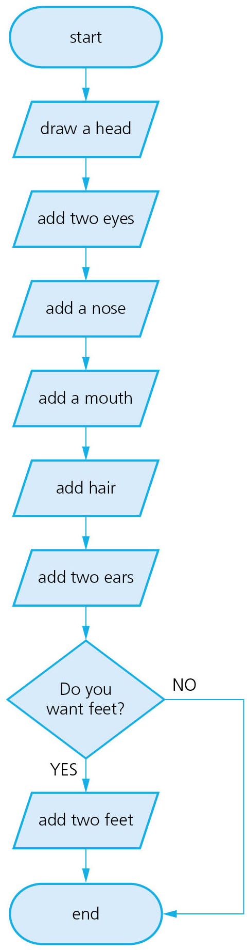
(4 marks for a flow diagram, with 1 mark deducted for each error. Drawing is an output not a process, so deduct 1 mark if students have used process symbols in place of output symbols)
b) For example:
Draw an oval head.
Add fringe hair.
Add boggle eyes.
Add an ordinary nose.
Add a tiny mouth.
Add two rollers feet.
Do you want ears?
If yes, add two floppy ears else no ears.
(4 marks for an algorithm with 1 mark deducted for not starting with an oval for the head, 1 mark deducted for each incorrectly named feature, 1 mark deducted for not specifying two ears or two feet and 1 mark deducted if the decision is not included)

Total 20 marks
Extension activity
Ask students to complete Activity 5.6: Infection risk app (Worksheet 5.6, slide 12).
Example answers
There are countless ways to program the app, but here are two suggested solutions, one in Scratch and one in Python.
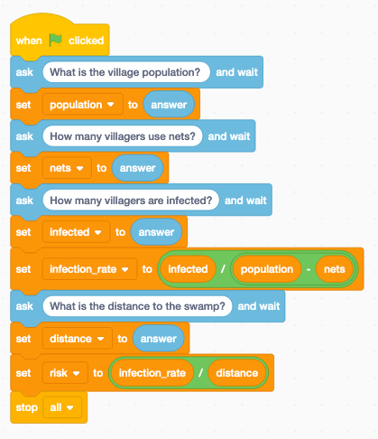

population = 0
nets = 0
infected = 0
infection_rate = 0
distance = 0
population = int(input('What is the village population? '))
nets = int(input('How many villagers use nets? '))
infected = int(input('How many villagers are infected? '))
infection_rate = (infected/(population - nets))
distance = int(input('What is distance to the swamp? '))
risk = (infection_rate / distance)
print('The risk is:')
print(risk)
Plenary
Ask students to reflect on the module (Slide 13).
Ask students to write their ideas on a sticky note with their initials and stick it to the wall or screen as they leave the class.
Stretch activities
Some students will find these activities reasonably straightforward and will be able to complete the tasks within the time available. If they have extra time this can be used to include suitable charts to make it easier to see the data and conclusions.
For part two of this unit, students who find the activity straightforward are provided with extension activities they can attempt using Scratch or Python to write a program to calculate the risk.
Support activities
Some students may find the spreadsheet task challenging but should be encouraged to work through it, using additional time in the final lesson, if they are unable to complete it for homework.
Some students may find the identification of the components in the potato head task straightforward but the associated algorithms and questions more challenging. Encourage them to think about the process for the flow chart and text algorithms and not to focus too much on the correct use of flow chart symbols at first.
Some students may benefit from being paired with another student with similar skills so that they can work together to complete the tasks.

